APPS IN SEQ MATH NAME_________________________

VOLUME HOMEWORK (10 POINTS)

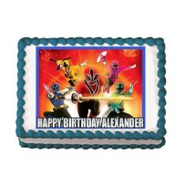

GROOM’S CAKE

The catering manager is in charge of ordering food and refreshments for a wedding reception with 260 guests. The caterer recommends a chocolate sheet cake for the groom’s table. This cake is in the shape of a rectangular prism measuring 24” by 36” by 2”. The cake will be cut into 2” by 3” by 2” pieces.

1. Draw a picture of the groom’s cake, labeling each side with its given measurements. Remember that the cake is three- dimensional. SHOW ALL WORK.(2 points)
2. How many pieces can be cut from the rectangular cake. *Hint: Calculate the volume of the entire cake, then calculate the volume of each piece.* Volume is the amount of space in a three-dimensional figure. ( 8 points)